**Installing Jenkins on Windows and Running:**

Requirements:

JDK should be installed on the system. As Jenkins was developed using Java, JDK should be installed on the system to run Jenkins.

Download the war package from Jenkins.io.

Now go to the folder where the war file is located in CMD, and run the following command.

java -jar jenkins.war --httpPort=9090

I have downloaded the war file to Jenkins folder in D drive so I am running the command from there.

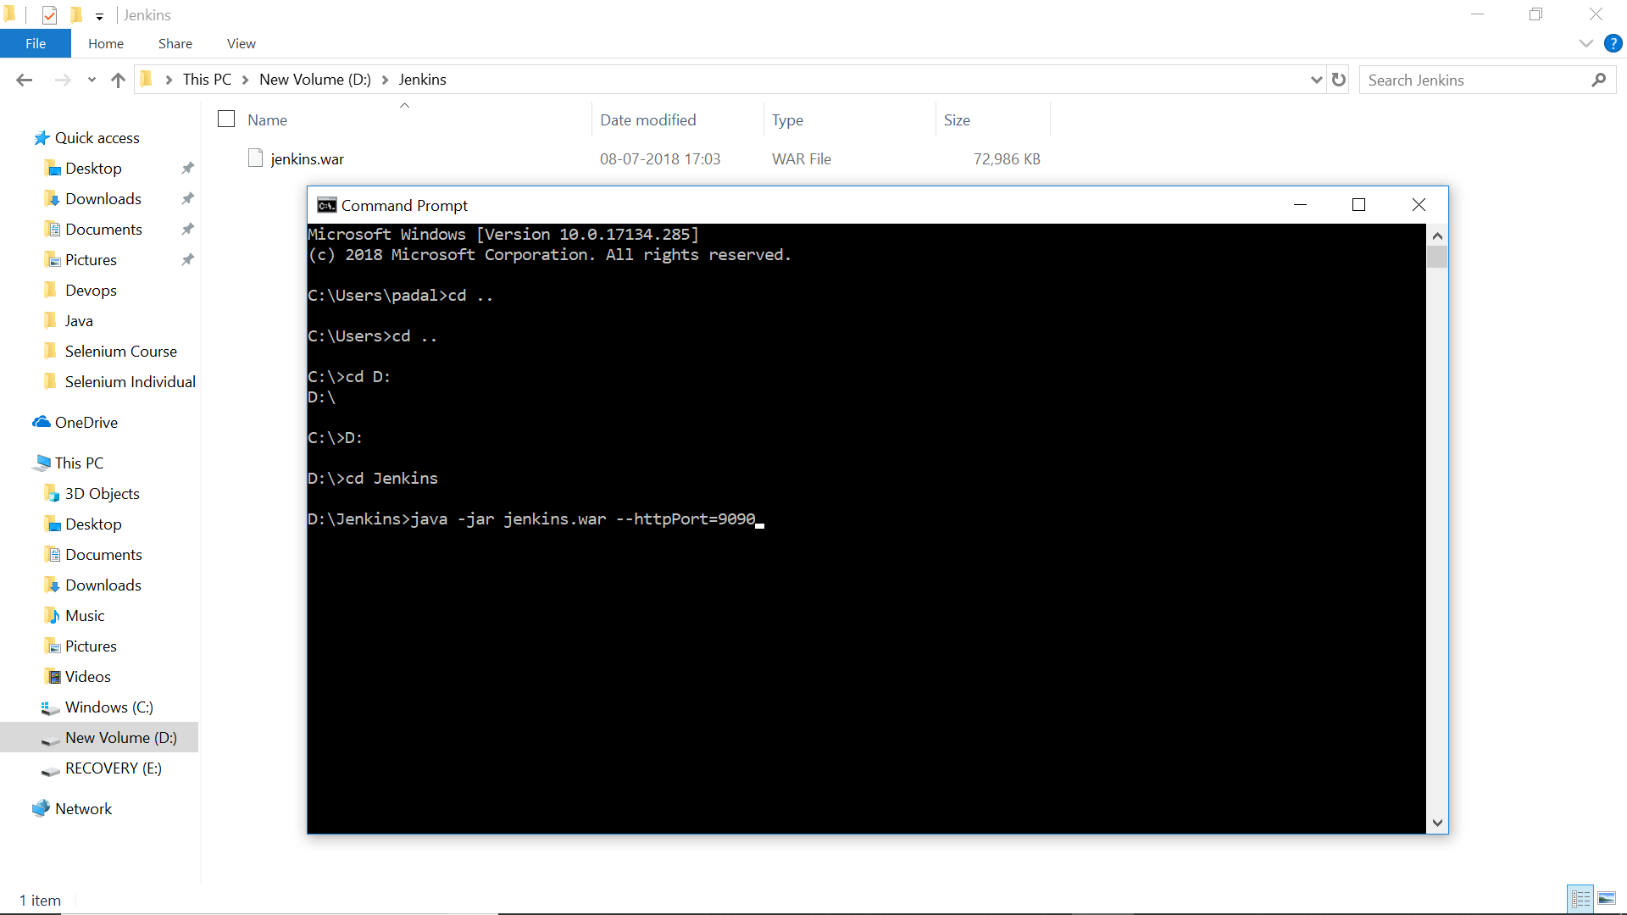

First time it will take sometime as it has to download some information from net. It stores all this information in a “.Jenkins” folder in “C:/User/YourUsername”. If you delete this folder then you can install Jenkins again.

Once all the installation is completed you can see the message on CMD that “Jenkins is fully up and running”

Once Jenkins is installed, it can be accessed at localhost:9090. The default port is 8080 but since I am using apache server running on that port I have specified Jenkins to use another port on 9090.

Now access Jenkins from web using the url <http://localhost:9090>

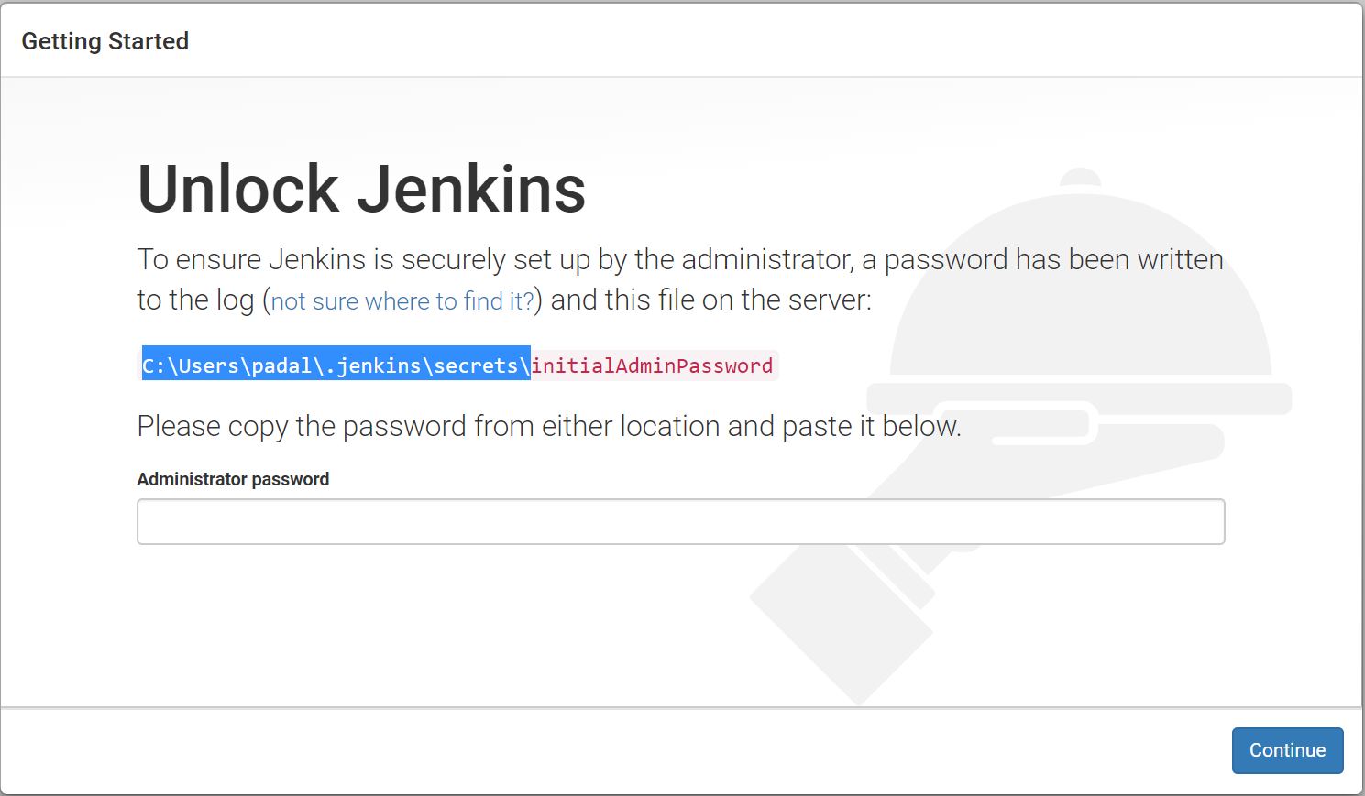

Once you open the above URL it will ask you to enter password. It will also show that the password is stored in a secret place and show you a path. Open the file and get the password and enter it. It is stored in “initialAdminPassword” file under secrets folder under “.Jenkins” folder.

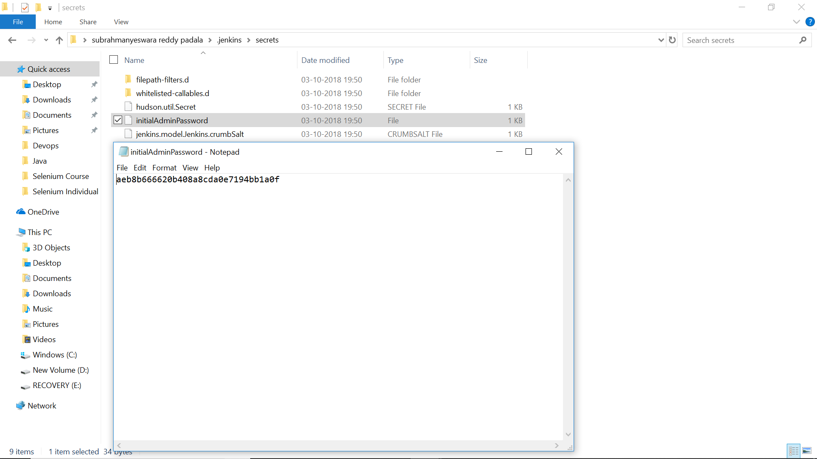

Copy the password and enter it into the password filed. Once you enter the password and click on continue it will open a screen asking you to select plugins. You can skip this to go to the next level.

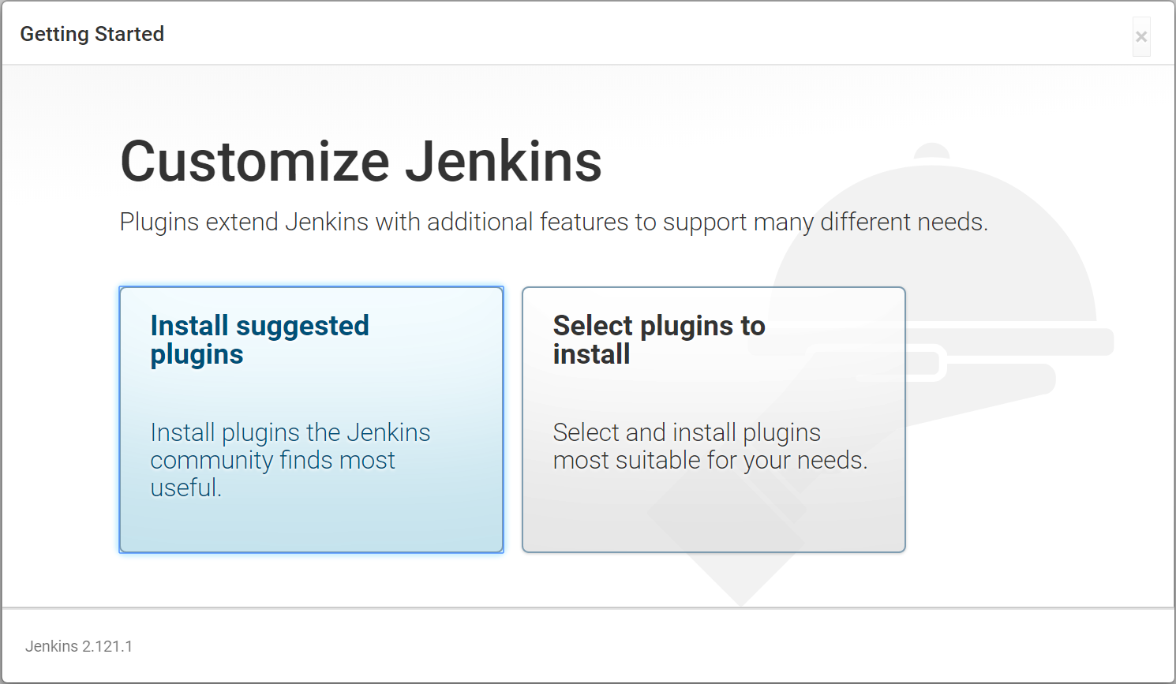

It will show a message that Jenkins is ready and click on continue

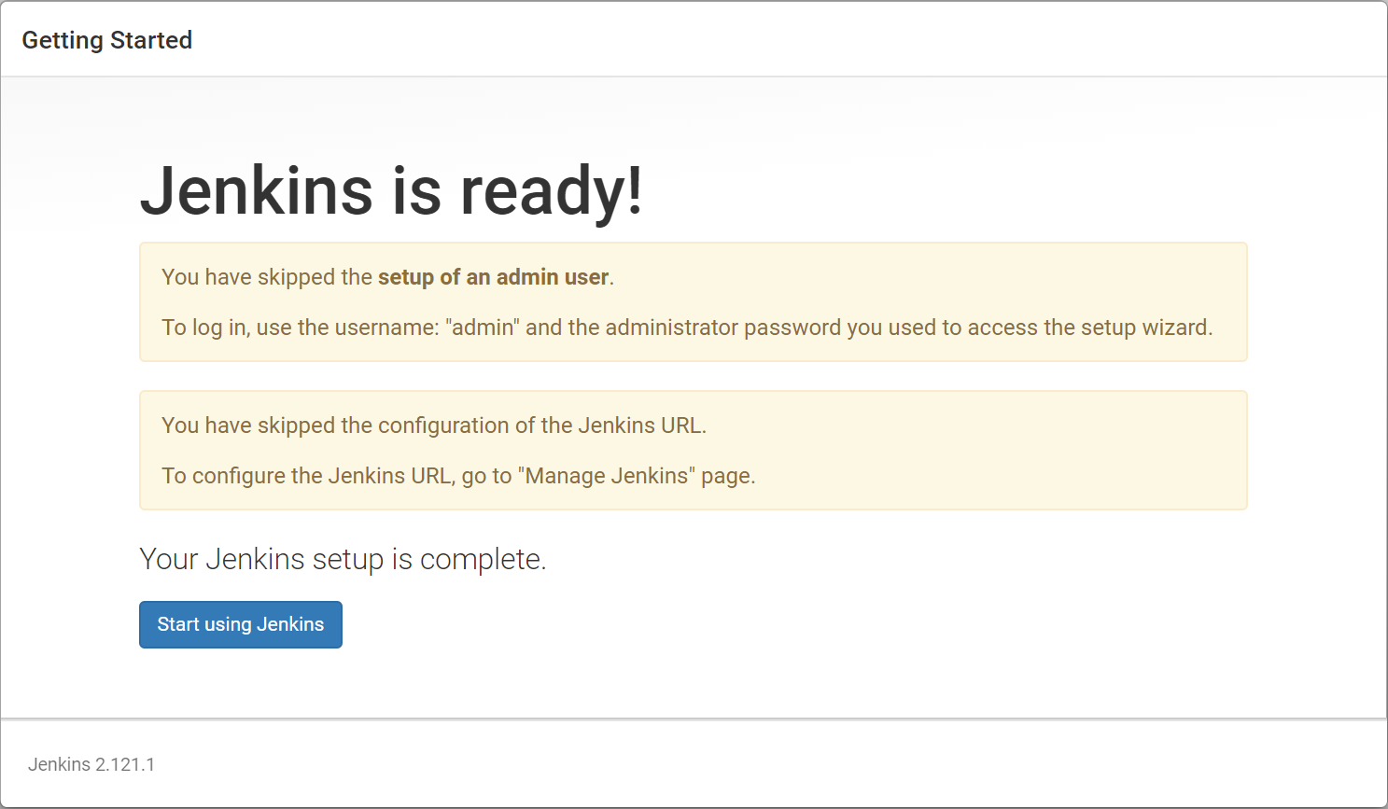

Now it should show the welcome screens. Now on the top right corner, if you move your mouse pointer over the admin link, it will show a dropdown arrow mark. Click on that and click on “Configure” link. Here you can change the password.

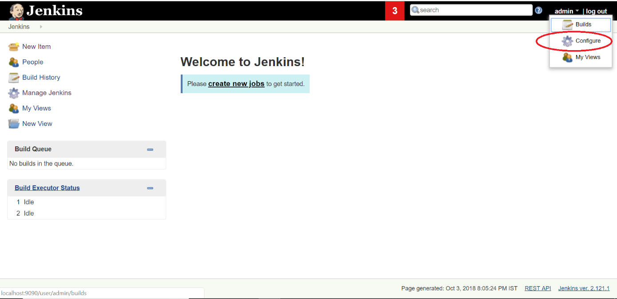

For easiness, I am changing the password to admin.

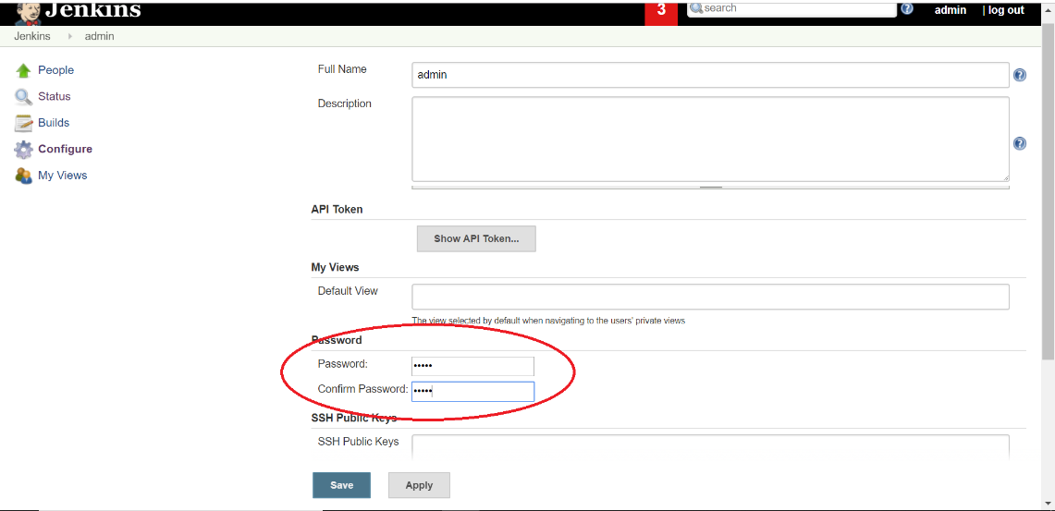

So now my username and password are

Username: admin

Password: admin

Next time when you want to start Jenkins, go to the same folder where you have the war file and run the command

java -jar jenkins.war --httpPort=9090

and this time it will be quick and if you open the url <http://localhost:9090>, it will ask you for the password and you can enter your password.